

# 19BIT0292

**Bhaumik Tandan**

DIGITAL ASSIGNMENT

OPEN SOURCE PROGRAMING

ITE1008

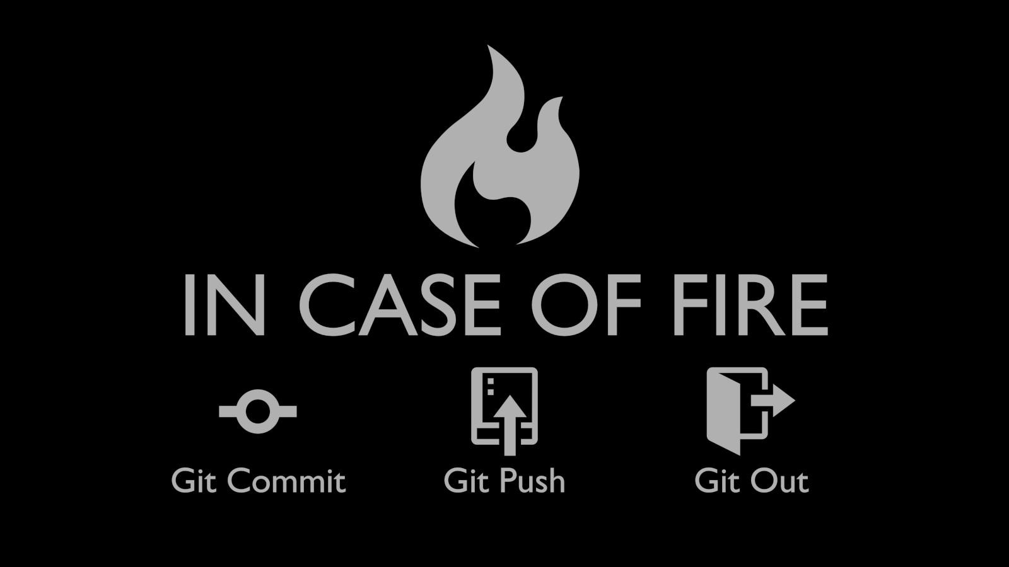

GIT

**ABSTRACT**

While creating a project, we come across different versions of it, and it a big hassle to manage and store all these version with different names and then remembering them. In this document we have talked about git, which is a open source distributed version control system (vcs), as well a source code management(scm) system. It keep tracks of all the versions of files of the project, as well as it also help us to role back to each version of it.

From 1991 to 2002 the updates in the development of Linux kernel were passed through archives and patches. Later in 2002 they began to use BitKeeper, which revoked it's free status in 2005. So there was a crisis in the collaborative development of Linux. Then the developer of Linux kernal, Linux Torvalds came with the idea of Git.

Later he launched git on 7th April, 2005, it revolutionized not only the development of linux but software development as a whole. It was release under (general public license)GPL’s open source license. It is written in C so it also avoids runtime overheads which is a problem is case of other high-level languages. As now a days the storage space is abundant, it can not only be used by developers for source code management , but common users can also use it to keep all the version of their documents and file.

This document contains the commands of git, which are most frequently used. We have also demonstrated how to keep the backup of our project on GitHubb and bring it back to our system.

**INTRODUCTION**

All the changes and history of the folder is stored in a .git folder called repository. In a centralized version control system there is a central repository in a system and all the code contributors update their changes in the central server.

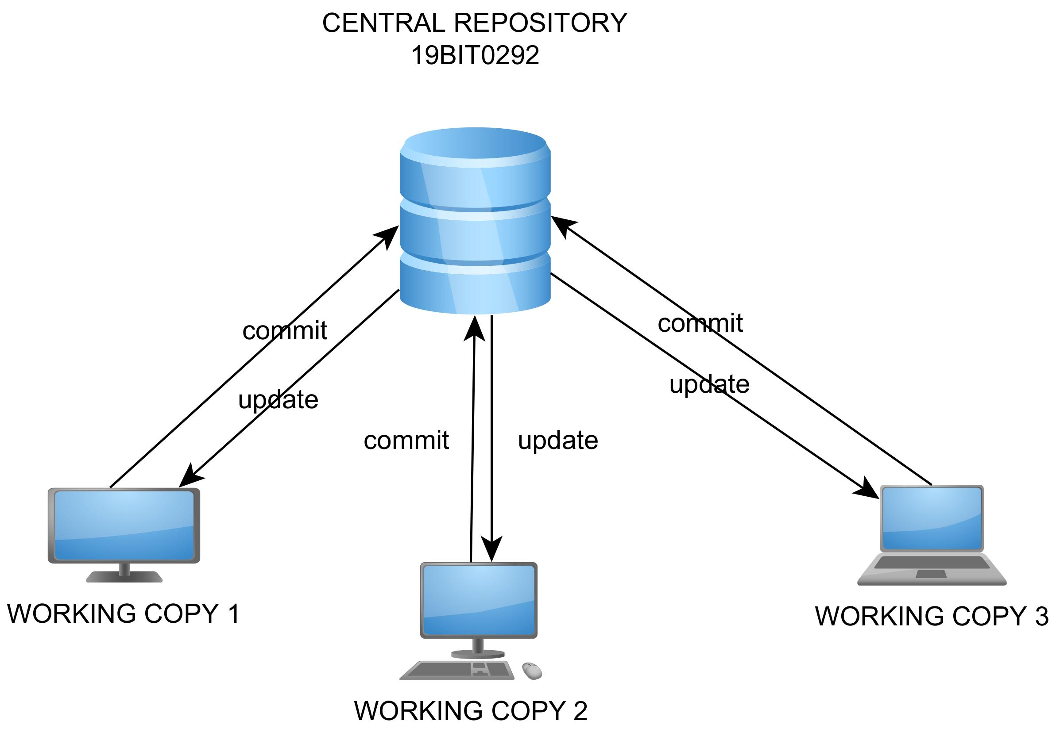

The biggest issue in this was single point of failure, i.e. in case of any fault in the central server the whole progress of the project is lost. But in case of distributed version control system like git there is a copy of the whole repository with each remote system and when needed they match their repository with a central repository hosted on the server.

There is no need for persist network connection between all the developers, and they can totally work offline. Whenever there is decentralization of any work, it makes the decision making quick. It also the case with distributed vcs as it increases the developer’s productivity because it increases the executions of small tasks like commit, checkout, etc. very quick.

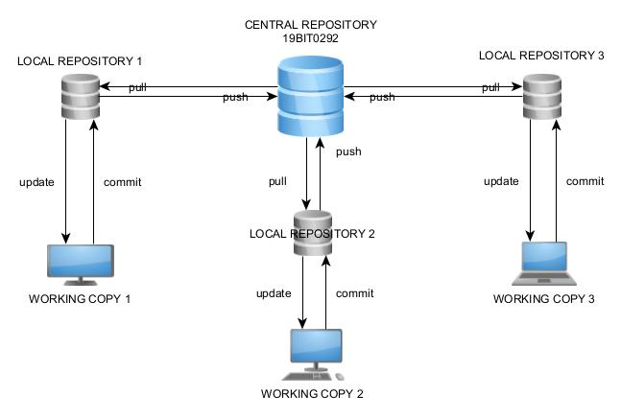

Since there are multiple copies of the repository locally with each contributor, the chances of losing data is very rare and also it gives a huge benefits in terms of speed, as most of the operations are performed locally.

In general when we work in our system we only have a single types of file.

But when we are using git, we can have four types of files:-

1) Untracked file:- A file in this stage does not get tracked and any changes made to it are not the part of our repository.

2) Modified file:- File in this stage are getting tracked but have been modified after the last commit.



3) Committed file:- This file is up to date with our current repository.

4)Staged file:- These files are ready to get committed.

We have to note that backups are not automatically made in case of git we have to do it manually by running some commands to do so. With respect to git in general we can categories our work space into 4 parts:-

1)Working directory:- This is the normal working space in our computer.

2)Staging Area:- Files in this area are ready to get committed.

3)Local Repository:- Files in this area are committed and stored in a version of the project.

4)Remote repository:-Files in this area are in any kind of remote centralized server or repository hosting website like GitHub, GitLab, etc.

**DEMONSTRATION STEPS**

**INSTALATION**

We can install git from [here](https://git-scm.com/downloads).

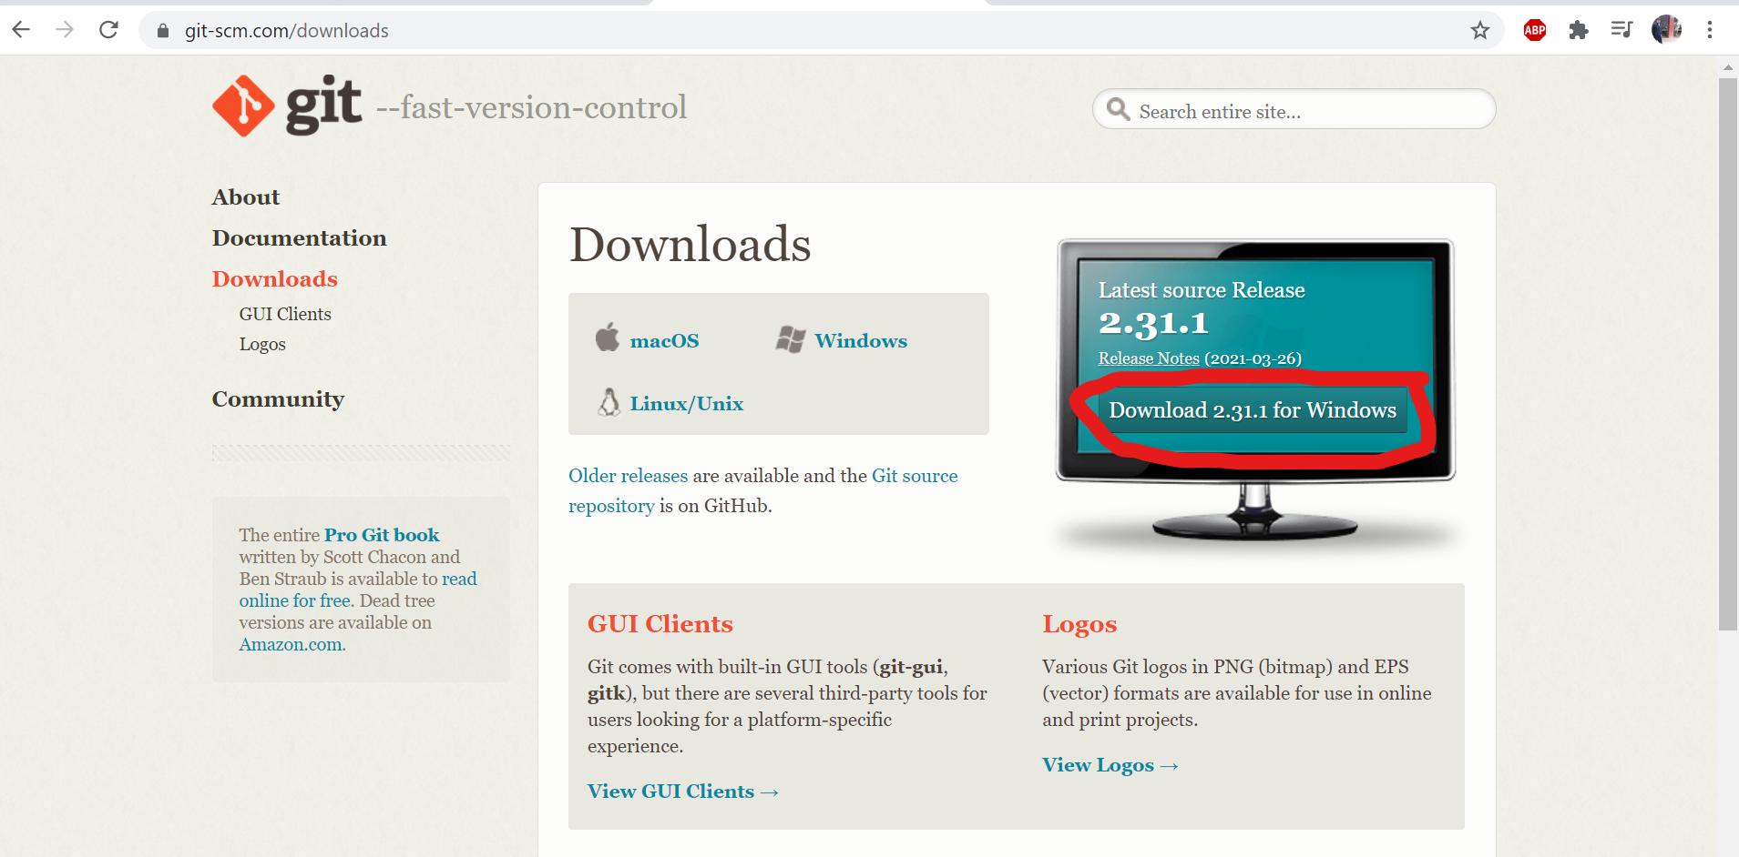

We can use any terminal in the system as well as we can also use GIT GUI, but in this demonstration we will use Git Bash. Open the folder and right click and select the option **“Git Bash Here”**

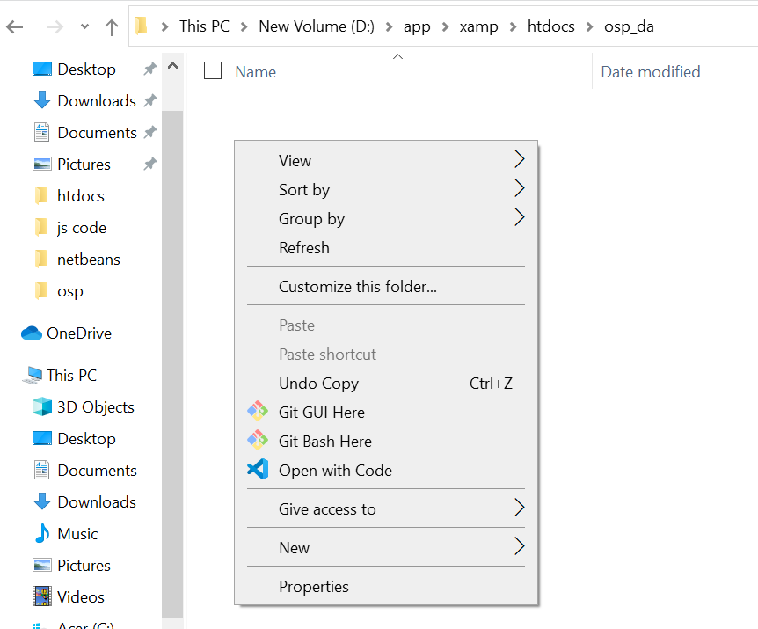

A terminal will open on that path as shown bellow

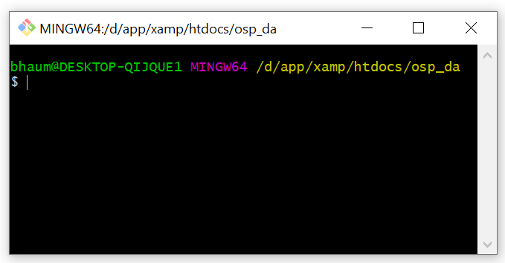

**INITIATING A REPOSITORY**

A new repository can be initiated in the folder by entering the command **git init**.

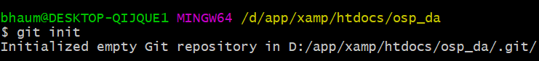

After entering the command we will observe that a new repository will be initiated in the folder and we will observe a folder labeled **“.git”** in the folder.

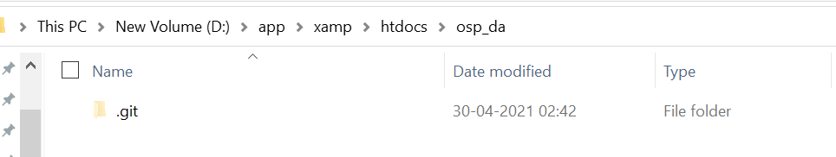

**CREATING A PROJECT WITH GIT**

We will create a login form, and with the help of which we will understand the use of git.

Suppose we have the following php file in our folder and we want to track changes using git here.

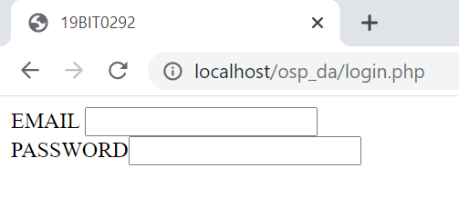<html>

<head>

<title>19BIT0292</title>

</head>

<body>

<form>

EMAIL

<input type="text" name="em"><br>

PASSWORD<input type="password">

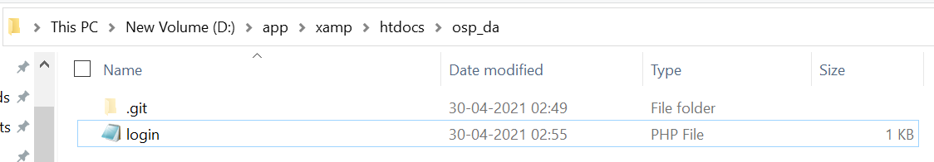</form>

</body>

</html>

In order to know the current status of the repository we can use the command **git status**.

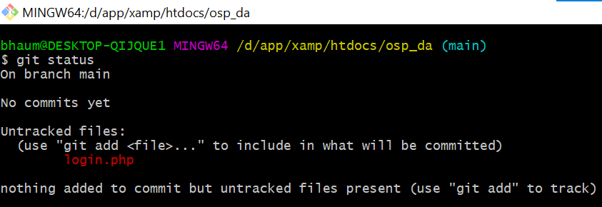

As We can see in the image above git is telling us that we have an untracked file named login.php and in order to add it to the staging area we have to run the command **git add login.php**.

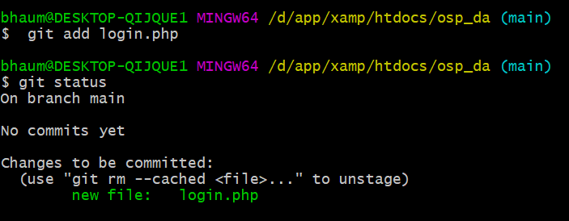

The file has been added to the staging area, we save the current version of the file using command **git commit login.php**.

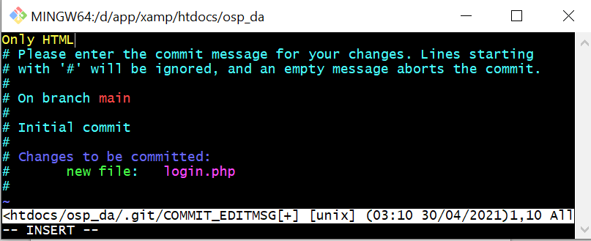

On entering the command we will observe that vim editor gets open and we can give the name to our commit.

If we want to see the log of all the commits we can use the command **git log**.

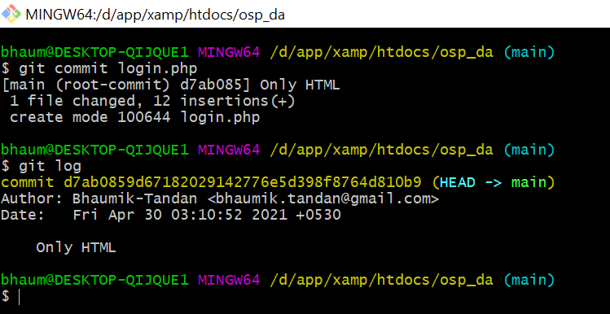

Our current version has been saved to the repository, now let's add some php to our script, display message if the email id and password matches our current password and also add an image to our login page.

After doing all the changes, the current status of our directory is:

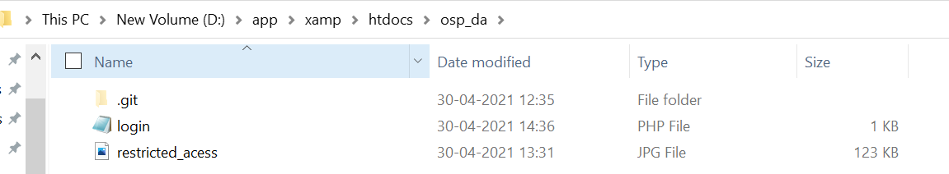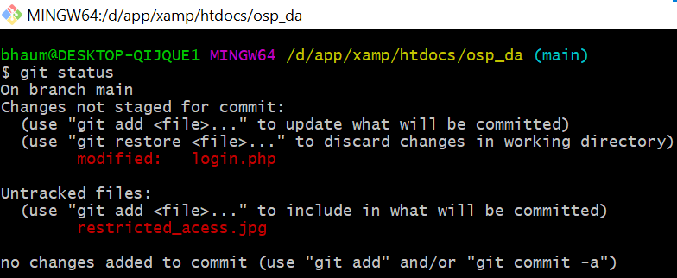

**CODE IN login.php**

<html>

<head>

<title>19BIT0292</title>

</head>

<body>

<img src="restricted_acess.jpg" alt="restrcted acess" width="300">

<form method="post">

EMAIL

<input type="text" name="em"><br>

PASSWORD<input type="password" name="pas"><br>

<button type="submit">Sign In</button>

</form>

<?php

if ($_SERVER["REQUEST_METHOD"] == "POST")

{

$email = $_POST['em'];

$password = $_POST['pas'];

if ($email=="bhaumik.tandan@gmail.com" && $password=="19BIT0292")

{

echo "WELCOME";

}

else

echo "WRONG CREDENTIALS";

}

?>

</body>

</html>

**OUTPUT**

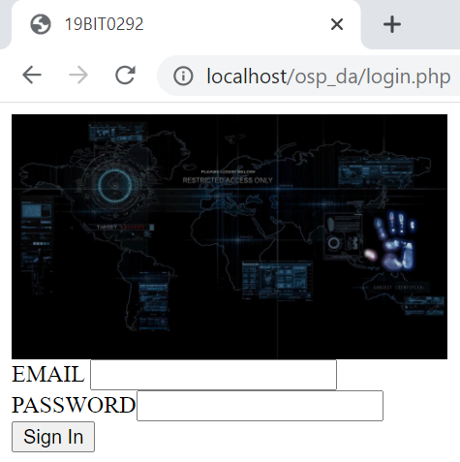

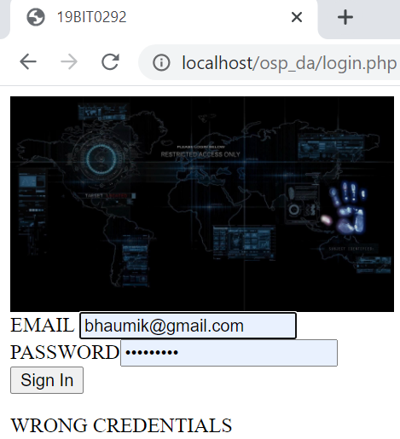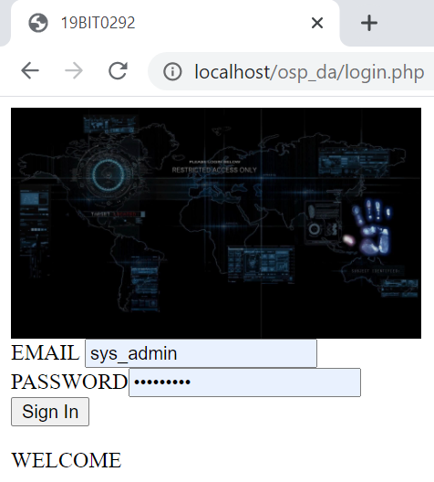

After doing all these changes in our directory, we have to first stage all the changes and then commit it, unlike last time we have multiple files, now inspite of staging the file one by one we will stage all the files by command **git add .** .

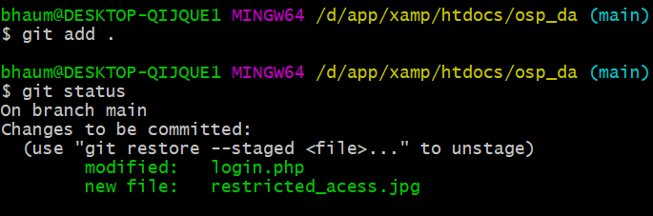

In place of writing “git commit” and then writing the message, we can directly give the name to the commit by writing the command **git commit -m “[Message]”**.

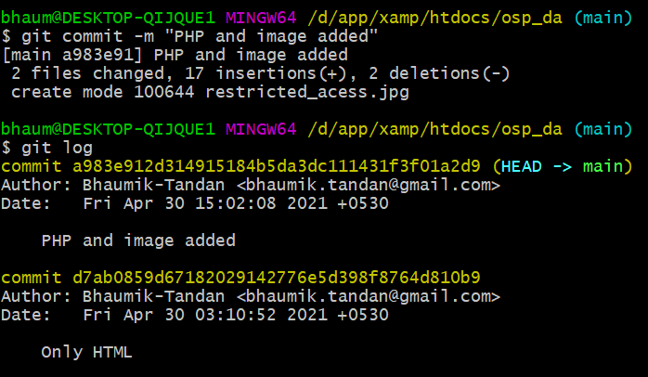

If suppose our files got deleted by mistake then we can match out current working directory and thus all our files will come back by using command **git checkout -f**.

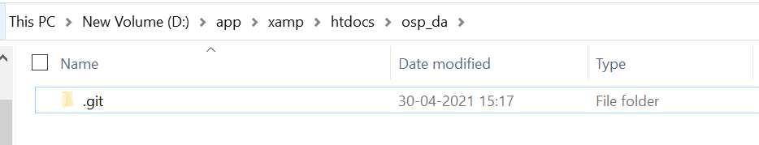

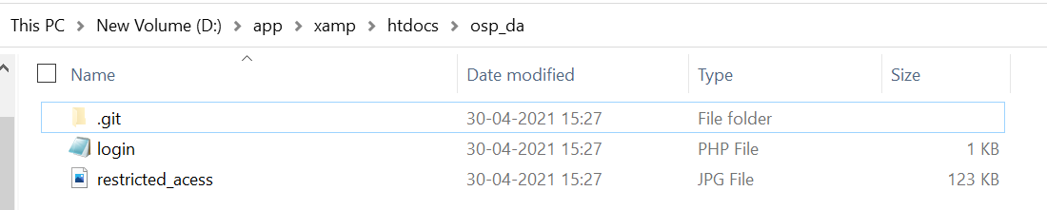

If we want to match only a particular file with the last commit we can also use the command **git checkout [file name]**.

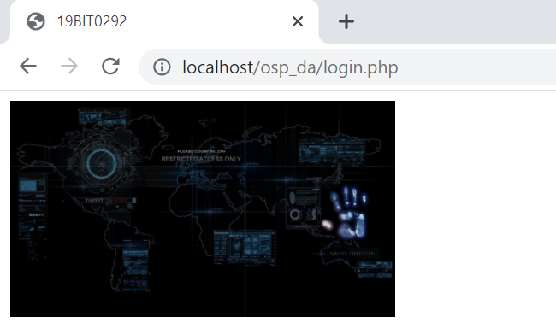

Suppose by mistake (as shown above) we deleted the form in “login.php”, we can go back to the last stage by command **git checkout login.php**.

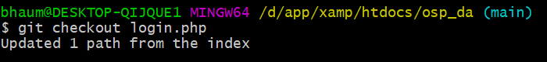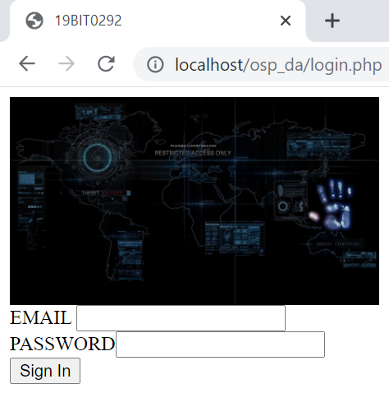

We can unstage our files by writing the command

**git restore -–staged [file_name]**.

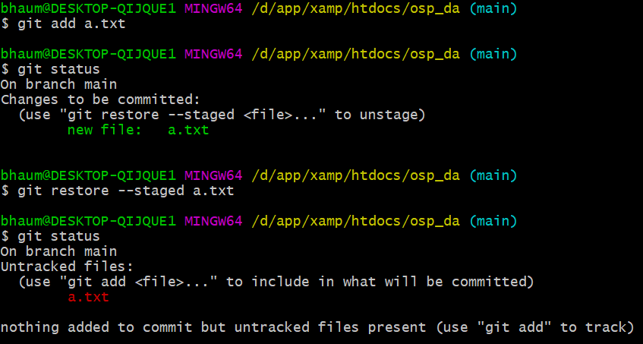

**PUSHING TO REMOTE REPOSITORY**

We already have repository, now lets push it on any cloud , we will use GitHubb for the same.

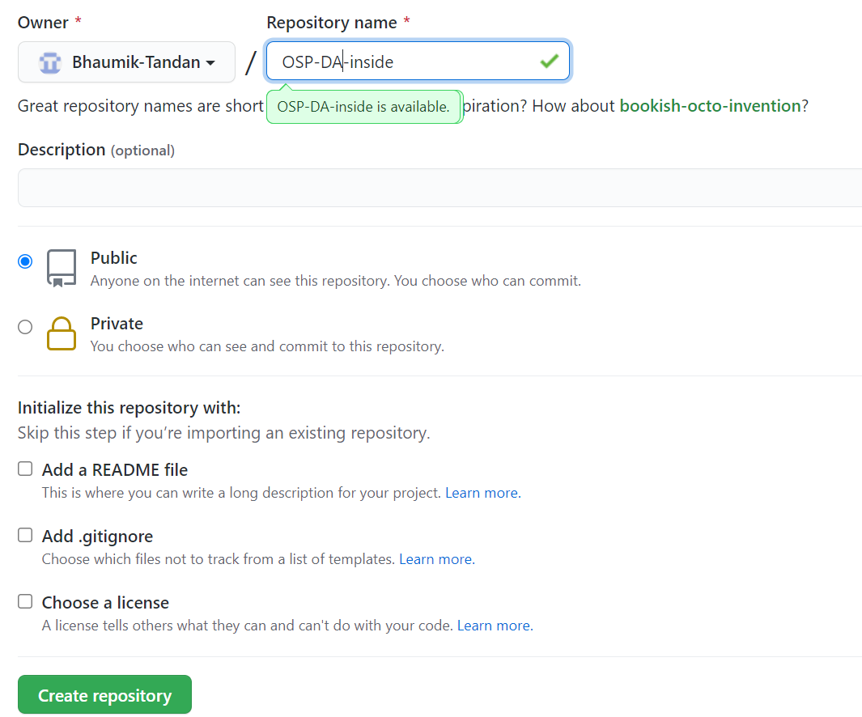

After creating a repository we will get a link like here we git:- <https://github.com/Bhaumik-Tandan/OSP-DA-inside.git>

We can push the repository to the above link by writing the command **git push -u main [link]**.

Note that we have used **-u** because if we want to again update the cloud repository so we just have to write **git push**.

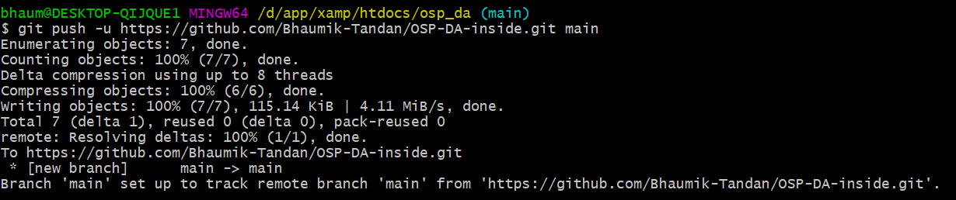

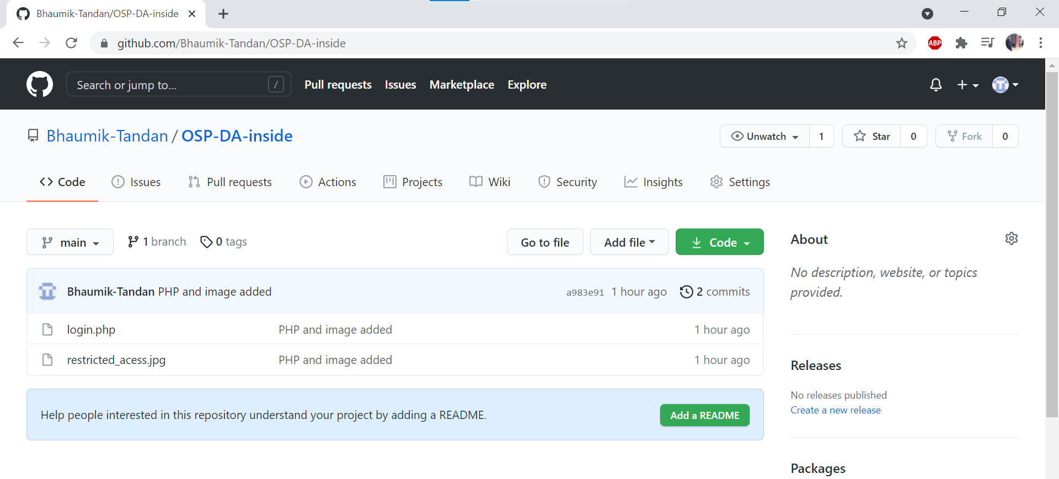

**CLONING CLOUD REPOSITORY**

If we delete our project from our computer and now we want it back in a folder in our system so we easily do it by opening git bash in the folder and entering the command **git clone [link]**.

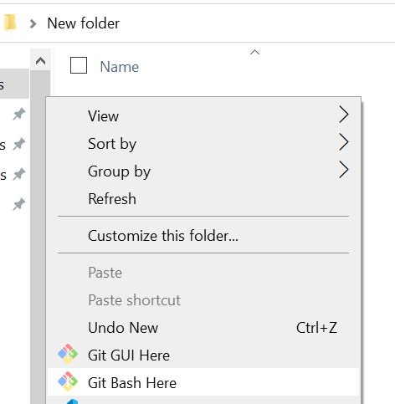

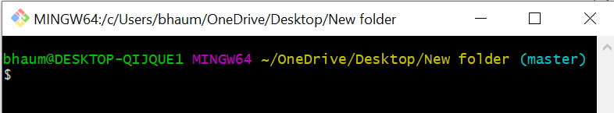

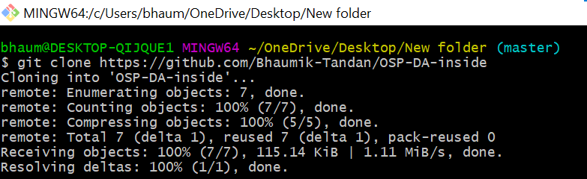

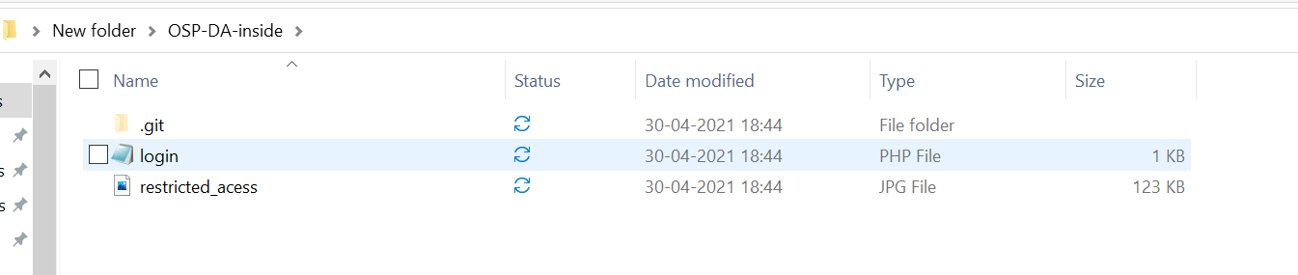

We an see we have all our files in our newly created folder, it not only has our files but also our whole repository if we run the the command **git log**, here so we can see out commit history.

